HyperCard Merchant Backend Operation Manual
V1.0

Merchant Backend Overview:
The merchant backend provides the following main functions: 1. Card display editing, 2. Card fee settings, 3. Card application records/asset records viewing.

Operation Manual:

1.Function Descriptions
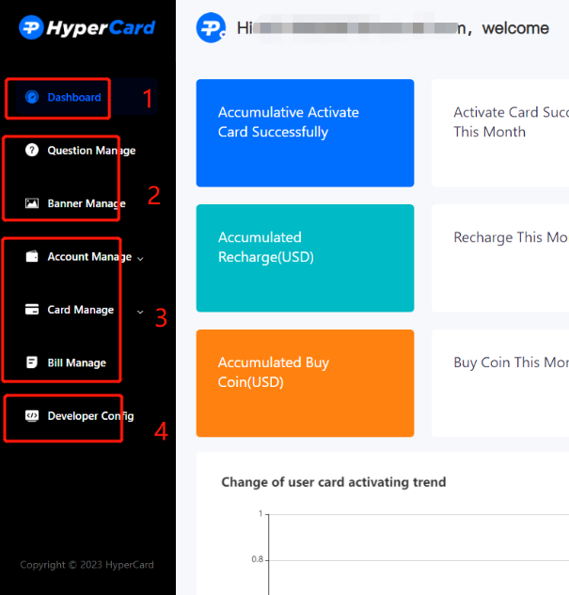

1.1 Dashboard
The global dashboard displays user registration, card sign-up, deposits, and other related activities.

1.2 FAQs/Banner Management
Manages FAQs and banner advertisements on the homepage (available only to SDK merchants).

1.3 Account Management/Card Management/Billing Management
Account Management: Manages account deposits for different currencies and displays merchant account balances for each currency.

Card Management: Manages basic information for cards issued by the platform.

Billing Management: Displays billing records for card sign-up, deposits, crypto purchases, and fund transfers for users under the merchant.

1.4 Developer Configuration
For initial merchant integration, settings for notification push, encryption method, IP access, and other business-related configurations are required. Refer to the following developer configuration instructions for details.

2.Card Configuration

2.1 Card Editing
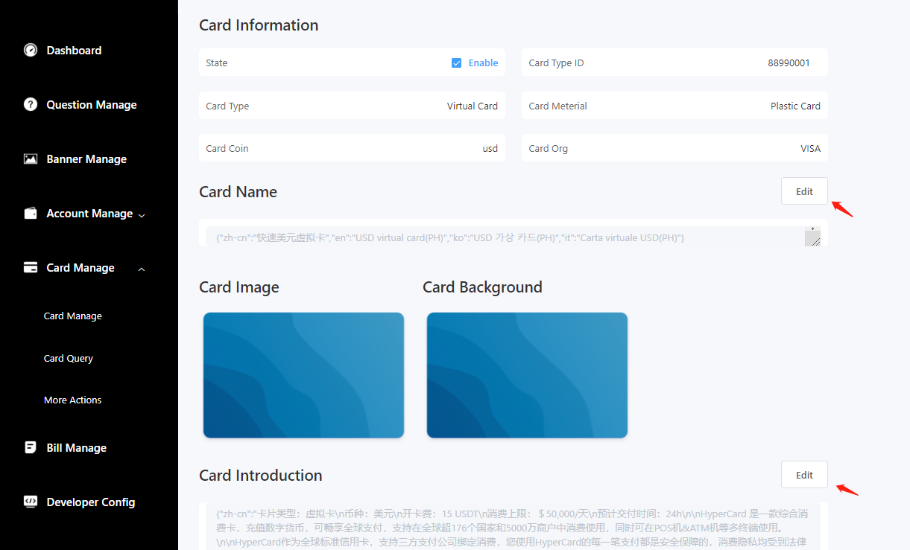
The card editing function allows for self editing and settings of the card. If not set, the default card sample image or text description provided by the platform will be used.

2.2 Card Sign-up Earnings/Deposit Earnings Rate (SDK merchants only)
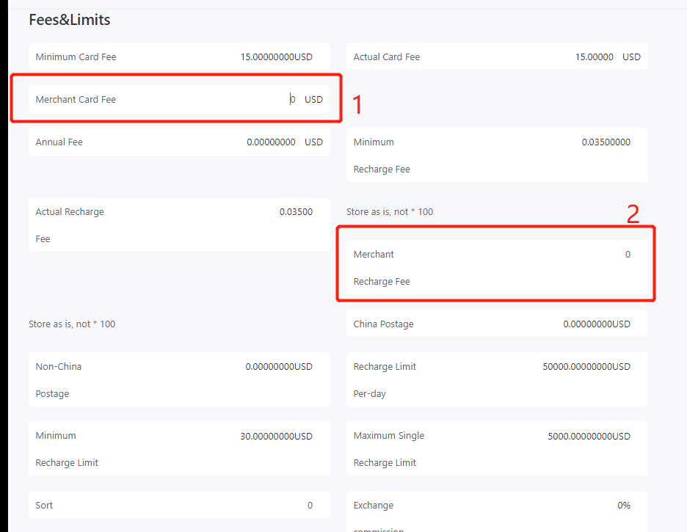
Card Sign-up Earnings: Sets the earnings for each card signed up by the merchant. The value should be greater than or equal to 0 in fiat currency.
Once set, the actual card sign-up fee will be calculated as the platform's minimum card sign-up fee plus the earnings value.

Deposit Earnings Rate: Sets the earnings rate for each deposit made by the merchant. The value should be greater than or equal to 0 as a percentage.

Once set, the actual deposit fee will be calculated as the platform's minimum deposit fee plus the earnings rate.

Note:
1. This display is exclusive to SDK merchants and can be edited.
2. API merchants do not have this display/editing feature; the values are predetermined and agreed upon by both parties.

2.3 Supported Currencies for Card Sign-up/Deposit/Crypto Purchase
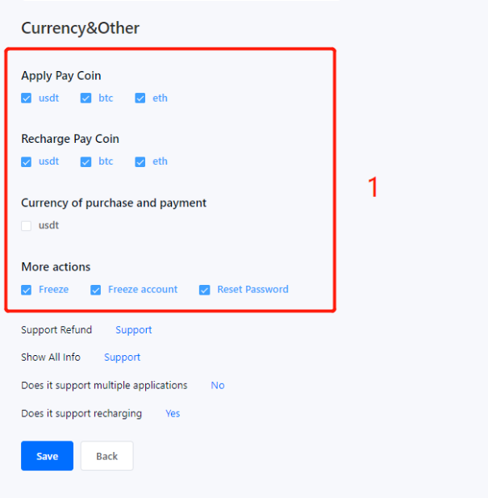

Configures the supported currencies. Contact the platform's integration personnel to add new supported currencies.

3.Developer Configuration

3.1 Push Notification Configuration
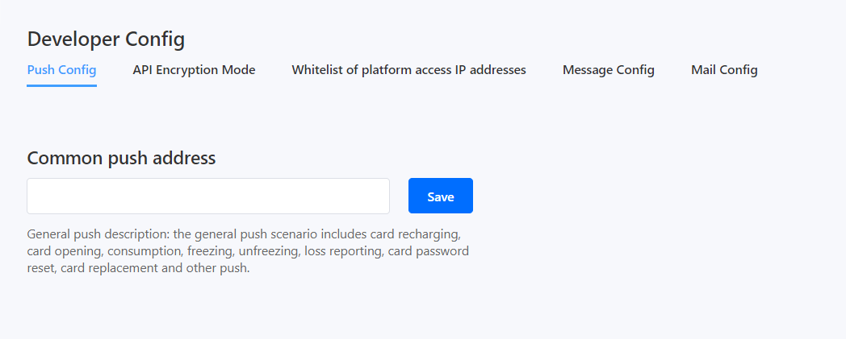
Push Notification: Universal push scenarios include card deposits, card sign-up, transactions, freezes, unfreezes, card loss, card password reset, card replacement, etc.
Note: Refer to the agreed format and address with the platform's technical team before configuration.

3.2 API Encryption Method
For the security of API interfaces, merchants need to exchange public keys with HyperCard. Merchants can configure their own public key on this page.
HyperCard assigns an API key to each merchant for identification. Merchants can click the "View" button to see their own API key and HyperCard's public key.
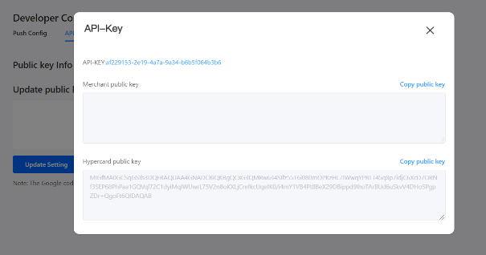

Refer to the specific encryption algorithm in the API documentation's "SHA256WithRSA Signature" section.

3.3 Platform Access IP Whitelist
For API interface security, only IP addresses on the whitelist are allowed to access HyperCard's API. Merchants can set the whitelist on this page.
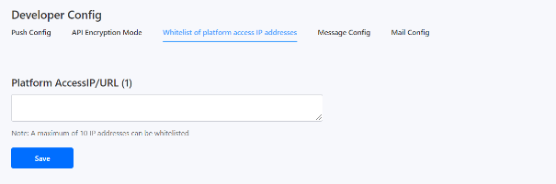

Note: If the merchant's own API also requires whitelisting, they need to contact HyperCard's operations personnel to obtain HyperCard's IP addresses.

3.4 SMS Configuration (SDK merchants only)
Reserved configuration, can use the same URL as the email configuration.
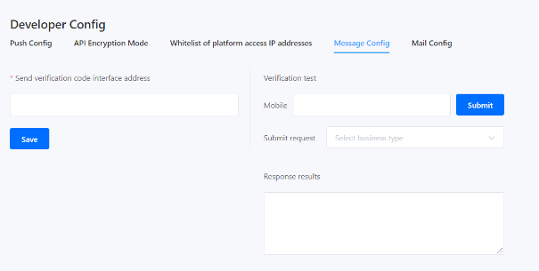

Note:
1. This display/editing feature is exclusive to SDK merchants.
2. API merchants do not require this configuration.

3.5 Email Configuration (SDK merchants only)
To verify the user's email validity during card sign-up, a code needs to be sent to the user's provided email address for verification. As different merchants have different requirements for the content of the verification code, the merchant needs to provide an interface for sending the verification code (interface definition can be found in the API documentation under "4.2 Email/SMS Verification Code Sending Interface"). When a verification code needs to be sent, the HyperCard service will call this interface, and the merchant will receive a request message and send the verification code to the user.
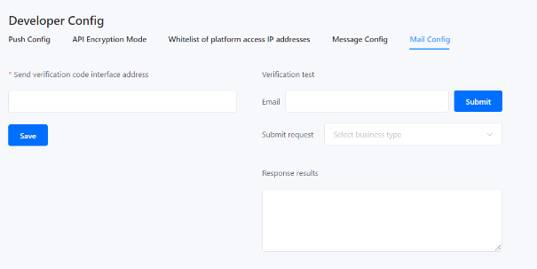

The "Verification Code Sending Interface" on the left side is provided by the merchant as the interface address.
After saving, you can enter your own email on the right side for checking to ensure that the email can receive the verification code.

Note:
1. This display/editing feature is exclusive to SDK merchants.
2. API merchants do not require this configuration.

